
TEESSIDE UNIVERSITY
MIDDLESBROUGH – TS1 3BA

School of Computing, Engineering and Digital Technologies
MACHINE LEARNING
CIS4035-N

MEDICAL INSURANCE COST PREDICTION
MODULE LEADER: DR. ALESSANDRO DI STEFANO
SUBMITTED BY: SAI RAM THOTA - D3675166

S
Word count: 3177 Words (Excluding references)
Date of Submission: 08/05/2024

Table of Contents
1. Abstract 2
2. Introduction 2
2.1 About the Dataset 2
3. Experimental Design 3
3.1 Statistical Data analysis and Visualization 3
4. Data Processing 9
4.1 Feature Engineering 9
5. Training the Regression Models 10
5.1 K-Nearest Neighbour Regressor 10
5.1.1 Loss Function for KNN Model 10
5.1.2 Tuning the hyperparameters for the KNN Regressor model. 10
6. Linear Regression Model 12
6.1 Loss Function for Linear Regression Model 12
6.2 Hyperparameter Tuning for Linear Regression Model 13
7.1 Training the Decision Tree Model 14
7.2 feature Importance in the decision tree regressor model. 14
7.3 Hyperparameter Tuning for Decision Tree Model 15
8. Random Forest Model 17
8.1 Training the Random Forest Regressor Model 17
8.2 feature Importance in the Random Forest Model 17
9.Result and Analysis 20
10. Model Accuracy 22
11. Reflect on professional, ethical, and legal issues in relation to the problem 22
12. Conclusion and Future Work 22
13. References 23

A Comprehensive Analysis for Medical Insurance Cost Prediction using Machine Learning Algorithms and Statistical Visualization

Abstract
This research project aims to develop and apply machine learning algorithms and statistical visualization methods to predict medical insurance costs accurately. By analysing a comprehensive dataset including medical records, demographic information, and insurance claims history, the study seeks to create predictive models for estimating future healthcare expenses for individuals. The project involves preprocessing and feature engineering of the dataset, followed by implementing various machine learning algorithms like linear regression, decision trees, or neural networks. Statistical visualization techniques will be used to understand the relationships between variables and their impact on insurance costs. The goal is to build a reliable predictive model to aid insurance providers and policyholders in healthcare planning and coverage decisions.

Introduction
Medical insurance cost prediction involves using data analytics and machine learning techniques to estimate future healthcare expenses for individuals. This process utilizes a comprehensive dataset comprising medical records, demographic information, lifestyle factors, and previous insurance claims. By analysing these variables, predictive models can be developed to forecast the potential costs of medical treatments and services for policyholders. Machine learning algorithms such as regression, decision trees, or ensemble methods are applied to learn patterns from the data and make accurate predictions. Statistical visualization techniques aid in understanding the relationships between different factors and their impact on insurance costs. The objective is to create a reliable predictive model that assists insurance companies in assessing risk, setting premiums, and optimizing resource allocation. Ultimately, accurate cost prediction enhances financial planning for both insurers and insured individuals, facilitating better healthcare management and coverage decisions.

2.1 About the Dataset
The dataset sourced from Kaggle comprises 1339 rows and 7 columns, offering vital insights for medical insurance cost prediction. This analysis aims to provide valuable insights for insurance companies to optimize pricing strategies and improve risk assessment. The data accessible via Kaggle.

3. Experimental Design
Experimental design involves planning and conducting scientific experiments systematically. It includes defining objectives, selecting variables, outlining procedures, and controlling for biases. Well-designed experiments ensure reliable results by minimizing variability and confounding factors.

3.1 Statistical Data analysis and Visualization
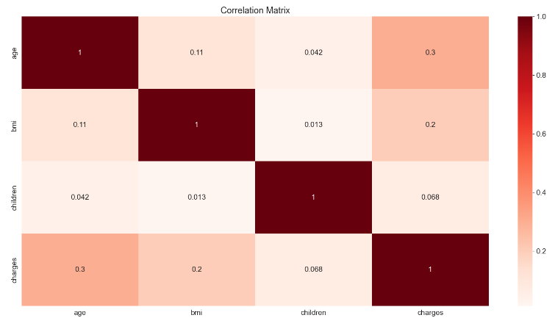
Fig. 1: Correlation between the features
Darker shades in the correlation matrix heatmap indicate stronger positive correlations between age, BMI, and number of children with insurance costs, suggesting their influence on higher expenses. Lighter shades imply weaker or negative correlations for sex, smoking status, and region, suggesting less impact or no direct correlation with costs. This visualization helps pinpoint factors closely related to insurance expenses, guiding further analysis and modelling in medical insurance cost prediction.
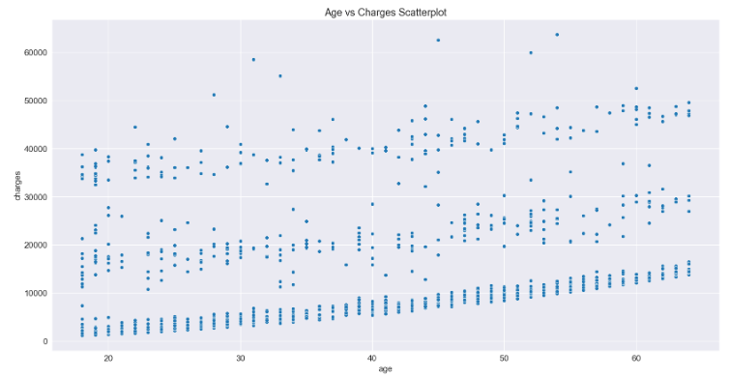
Fig. 2: Scatterplot between the Age Vs Charges According to the Smoker, Sex, Region, and Children
The scatterplot visualizes the relationship between age and insurance charges, categorized by smoker status, sex, region, and number of children. It shows how charges vary based on these factors: for instance, highlighting differences in charges between smokers and non-smokers, males and females, different regions, and number of children.

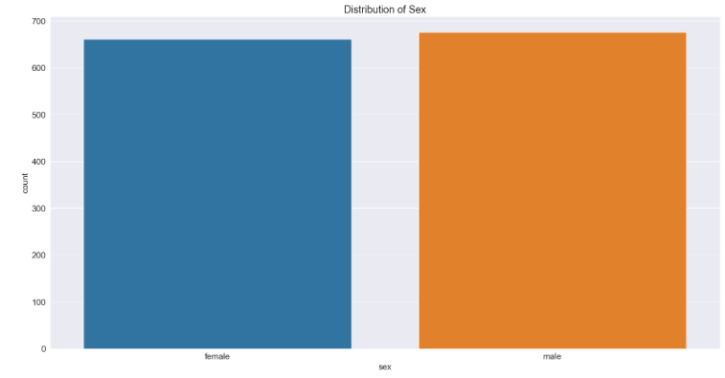
Fig. 3: Distribution of Sex between the male and female
The distribution of sex in the dataset reveals an almost 1:1 ratio between males and females, indicating a balanced representation of genders. This information is crucial for understanding gender demographics and potential influences on variables like medical insurance costs or other outcomes studied in the dataset.
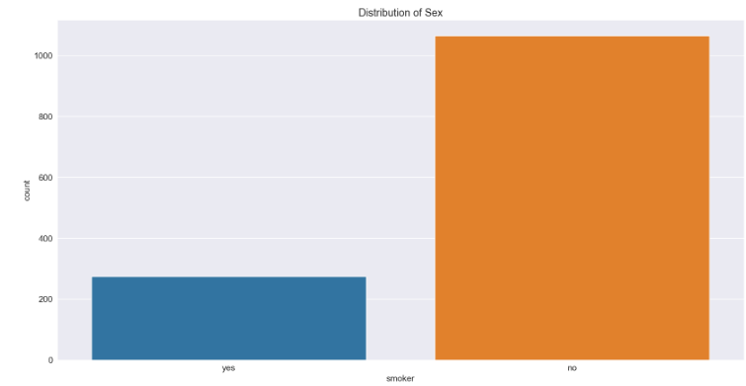
Fig. 4: Smoker Analysis
It appears that approximately 80% of the customers in the dataset are non-smokers. When examining the distribution of smoking status by sex, the data may reveal insights into gender disparities among smokers and non-smokers, highlighting potential patterns or differences in health behaviours and associated insurance costs.
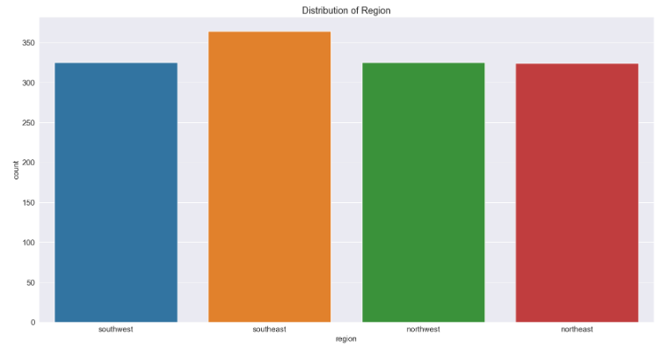
Fig.5: Distribution of region
The distribution of region shows a predominance of customers from the southeast region within the dataset. This observation suggests a regional concentration that could be significant for analysing geographical influences on variables like insurance costs or health-related outcomes, potentially reflecting regional health trends or demographic patterns.

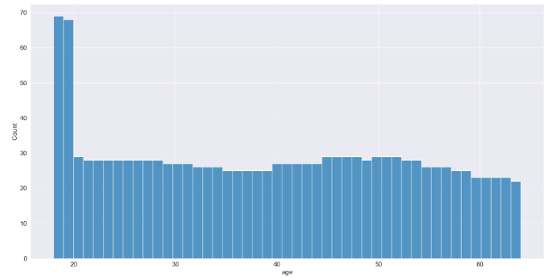
Fig. 6: Age analysis
The analysis of ages in the dataset reveals a uniform distribution, indicating an even spread of individuals across different age groups. This observation is important for understanding the age demographics represented in the dataset and its implications for studying factors such as medical insurance costs or health outcomes across various age brackets.
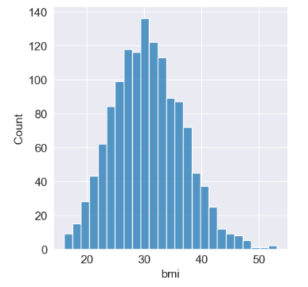
Fig.7: Distribution of BMI (Body Mass Index)
The even distribution across age groups in the dataset indicates a well-represented sample without any dominant age group. This balance ensures diverse demographic coverage, crucial for unbiased analysis of factors related to medical insurance costs or health outcomes across various age ranges.
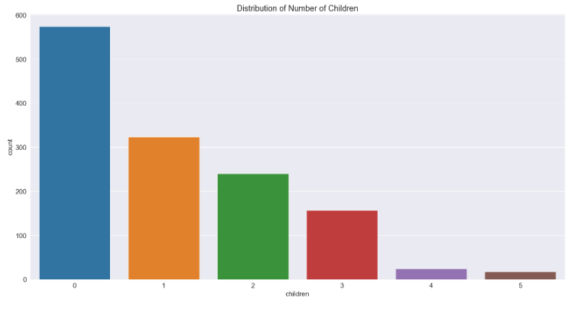
Fig.8: Distribution of Number of Children
The distribution of the number of children in the dataset shows varying counts across different categories, indicating the diversity of family sizes among the individuals. This analysis is essential for understanding demographic characteristics and potential influences on variables such as medical insurance costs or health-related outcomes based on family size or parental status.
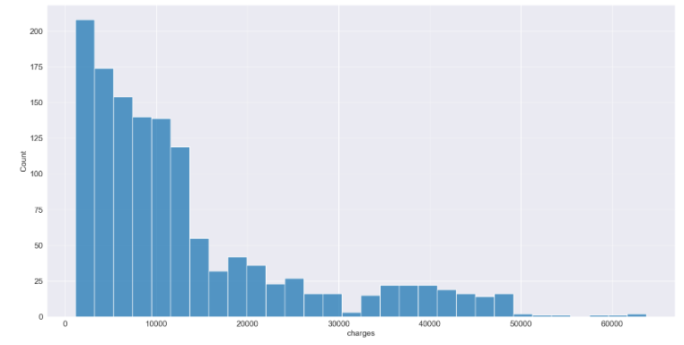
Fig.9: Analysis on charges
An analysis of charges in the dataset reveals a wide range of values, suggesting significant variability in medical insurance costs incurred by individuals. This analysis is crucial for understanding cost distributions, identifying factors influencing higher or lower charges, and informing insurance pricing strategies based on demographic, health, or lifestyle variables. Understanding the patterns and trends in charges can assist in predicting and managing healthcare expenses effectively.

4. Data Processing

4.1 Feature Engineering
Feature engineering in medical insurance cost prediction involves selecting, transforming, and creating meaningful features from the dataset to enhance model performance. This process includes encoding categorical sex or region into numerical representations, scaling numerical features age or BMI to a common range, and potentially creating new features such as interactions between variables (e.g., BMI multiplied by smoking status).
A common formula used for predicting medical insurance costs (Y) based on features (X) could be represented as:
Y=β0​+β1​X1​+β2​X2​+…+βn​Xn

where:
- Y is the predicted insurance cost,
- β0 is the intercept,
- β1, β2, ……, βn are coefficients,
- X 1, X 2…., X n are the engineered features derived from the dataset.
In this formula, the coefficients β1, β2, ……, βn are estimated through machine learning algorithms like linear regression, which learn to predict insurance costs based on the engineered features. Feature engineering plays a critical role in improving model accuracy and interpretability for medical insurance cost prediction.

5. Training the Regression Models
Training regression models fits algorithms to data to establish relationships between features and target variables. In medical insurance cost prediction, models like Linear Regression, Decision Tree Regression, and Random Forest Regression use features like age, BMI, smoking habits, and region to predict charges. They learn from historical data to forecast future expenses, aiding insurers in risk assessment and resource allocation.

5.1 K-Nearest Neighbour Regressor

5.1.1 Loss Function for KNN Model
Root Mean Squared Error (RMSE) is a commonly used metric to evaluate the performance of regression models. The Root Mean Squared Error (RMSE) for the training data is approximately 8488.97, while for the validation data, it is around 9857.54. These values indicate the average magnitude of errors between predicted and actual values.

5.1.2 Tuning the hyperparameters for the KNN Regressor model.
Tuning the n_neighbors Hyperparameter
Tuning the hyperparameters for the KNN Regressor model involves optimizing key parameters like the number of neighbors (n_neighbors), the weight function (weights), and the leaf size (leaf_size). By systematically adjusting these parameters, we aim to enhance the model's predictive performance. In this process, we observed that setting n_neighbors to 1 resulted in a training error of 0.0, indicating potential overfitting. However, with n_neighbors set to 11, the validation error decreased to approximately 9789.75, suggesting improved generalization and better model performance on unseen data.
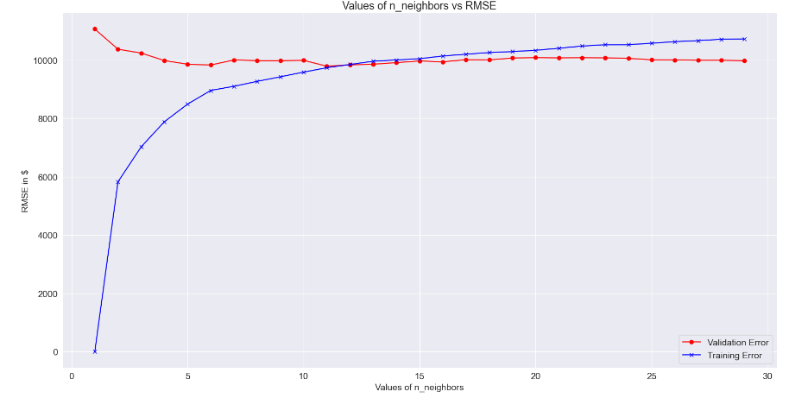
The KNN model shows overfitting with k values of 1 and 2, leading to higher RMSE on training data. However, performance improves with higher k values, peaking at k = 11 on the validation set. This indicates better generalization with more neighbours. Consequently, tuning the model with k = 11 aims to optimize performance and minimize errors in medical insurance cost prediction.
Tuning the Weights Hyperparameter
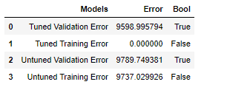
The model's performance is optimal when the weights hyperparameter remains at its default value. Tuning the hyperparameter does not significantly affect the training error, which remains at 0. However, on the validation set, the tuned model yields a lower error compared to the untuned one, indicating improved generalization. Therefore, retaining the default value for the weights hyperparameter is preferable for achieving better validation performance in medical insurance cost prediction.
Tuning Leaf Size Hyperparameter
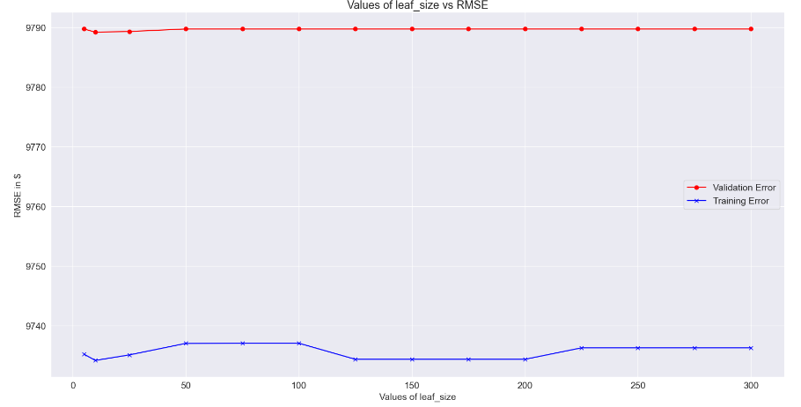
Through a systematic exploration of leaf_size values ranging from 5 to 300, we found that setting the parameter to 10 minimized the RMSE for both training and validation datasets. Thus, we determined that leaf_size = 10 optimally enhances our model's predictive accuracy for medical insurance cost estimation.

6. Linear Regression Model

6.1 Loss Function for Linear Regression Model
The RMSE values for training and validation predictions of the Linear Regression model are 6175.14 and 5806.05, respectively. These metrics quantify the average deviation of predicted values from actual values, providing insights into the model's accuracy.
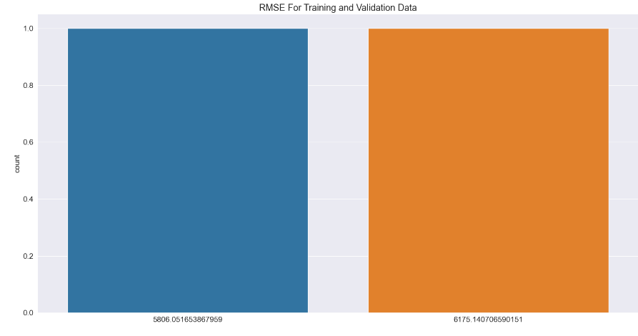

6.2 Hyperparameter Tuning for Linear Regression Model
Tuning Hyperparameter normalize.
Tuning the normalization hyperparameter in linear regression yielded marginal differences in performance. With normalization set to False, RMSE was approximately 6175.14 for training and 5806.05 for validation. When set to True, RMSE slightly increased to around 6180.30 for training and 5806.23 for validation. These results suggest that normalization has minimal impact on model performance.
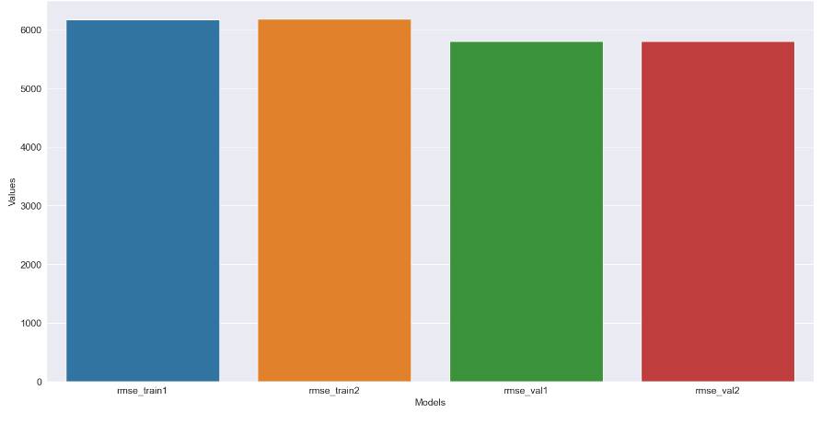

Tuning Hyperparameter fit intercept
The fit intercept hyperparameter tuning in linear regression yielded consistent RMSE values for both training and validation sets, irrespective of its setting (True or False). When set to True, RMSE values hovered around 6175.14 for training and 5806.05 for validation. Likewise, when set to False, RMSE values remained steady at approximately 6175.14 for training and 5806.05 for validation. This indicates minimal influence of including or excluding an intercept term on model performance.
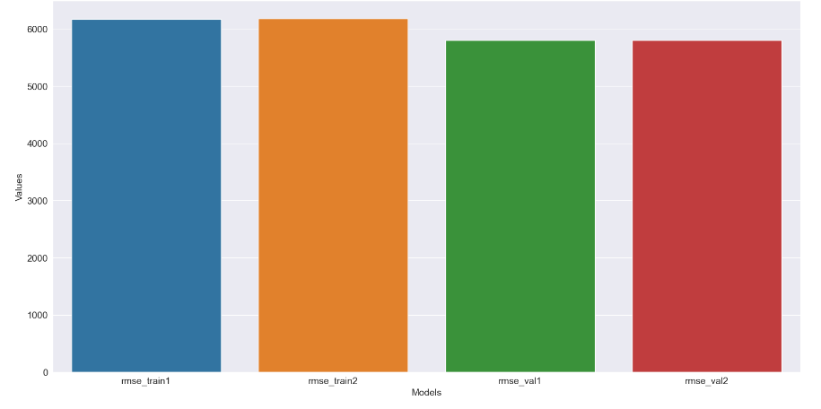7. Decision Tree Model

7.1 Training the Decision Tree Model
The decision tree model exhibits severe overfitting to the training data, indicated by an RMSE of 0.0, while significantly higher RMSE of 7061.11 is observed for the validation data. To address this issue, hyperparameter tuning is imperative to mitigate overfitting and enhance model generalization.

7.2 feature Importance in the decision tree regressor model.
The feature importance analysis of the Decision Tree Regressor Model highlights the pivotal role of the "smoker_no" column. It indicates that smoking status significantly influences predicted insurance costs, with non-smokers having lower costs. Hence, "smoker_no" holds the highest weight in the model's decision-making process, underscoring its importance in determining insurance expenses.
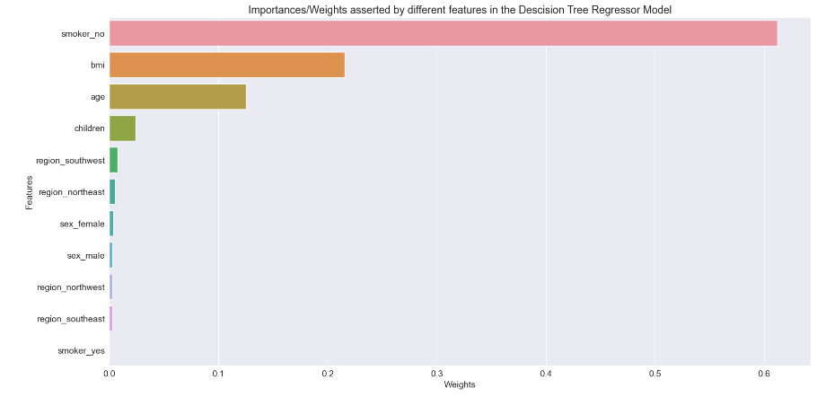

7.3 Hyperparameter Tuning for Decision Tree Model
Tuning the Hyperparameter max_depth
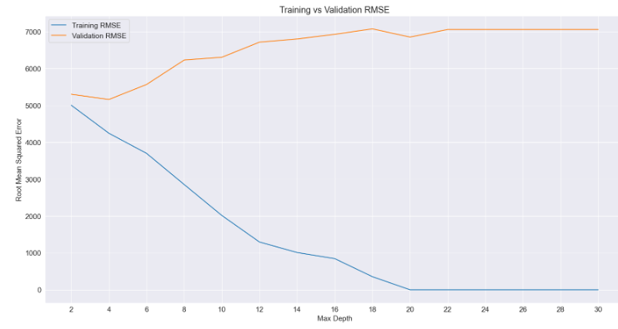
The examination illustrates that the model attains its peak performance with a "max_depth" value of 4. However, as the "max_depth" increases beyond this threshold, the model begins to overfit the training data. Consequently, we will adjust the hyperparameter "max_depth" to optimize the model's efficacy in generalizing to unseen data, focusing on its performance on the validation dataset.
Tuning the Hyperparameter max_leaf_nodes
The model achieves its optimal performance on both the training and validation sets when the "max_leaf_nodes" hyperparameter is set to 8. This configuration minimizes the root mean squared error (RMSE) on both datasets. Therefore, we will adjust the model's hyperparameters accordingly to enhance its ability to generalize while maintaining low error rates on unseen data.
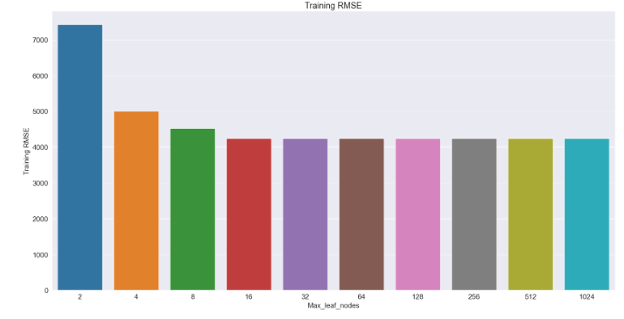

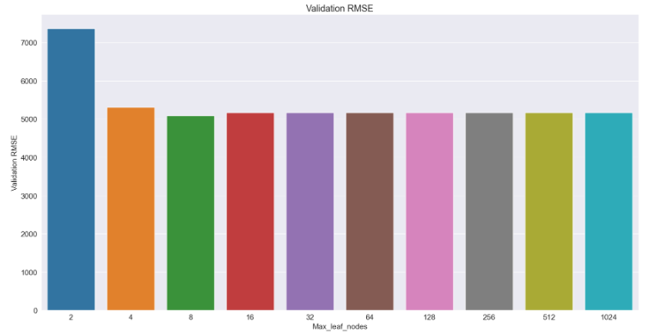

8. Random Forest Model

8.1 Training the Random Forest Regressor Model
Random Forest is a versatile ensemble method combining multiple decision trees to enhance predictive accuracy and address overfitting. Specifically designed for regression tasks, Random Forest Regressor predicts continuous values. However, overfitting can occur without proper parameter tuning. This involves adjusting settings like the number of trees (n_estimators), tree depth (max_depth), and minimum samples for node splitting (min_samples_split). By default, Random Forest has 100 decision trees, but tuning these parameters is crucial for optimizing performance and mitigating overfitting.

8.2 feature Importance in the Random Forest Model
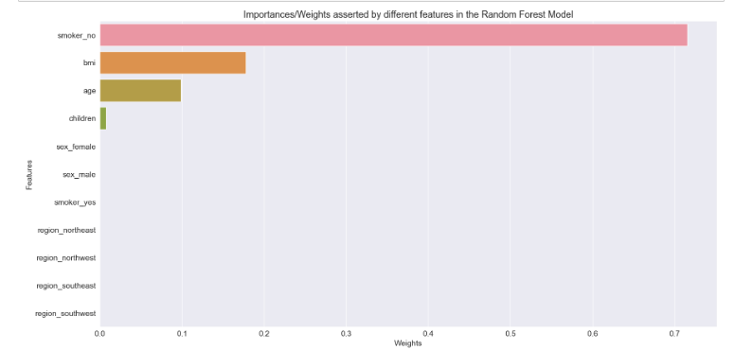
The feature importance analysis of the Random Forest model reveals that the most significant predictor of insurance cost is whether the individual is a smoker or not, with a weight of 0.715. This is followed by BMI (0.178) and age (0.098). Other features such as children and sex have negligible importance in this model. This information aids in understanding which variables are most influential in determining insurance costs, allowing for targeted interventions or feature selection strategies to improve model performance.
8.3 Hyperparameter Tuning for Random Forest Model
Tuning the hyperparameter n_estimators
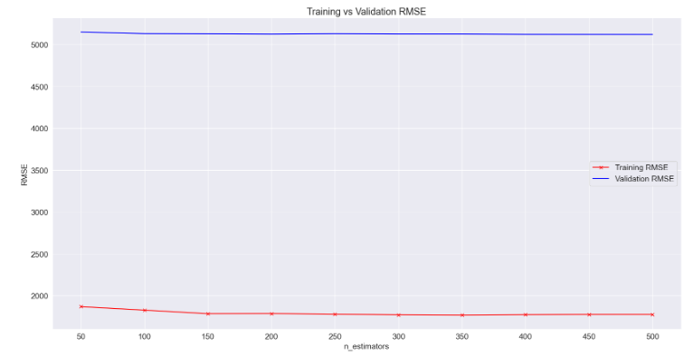
Tuning the hyperparameter n_estimators involve finding the optimal number of decision trees to include in the Random Forest model. In our analysis, we observed that the model achieved the lowest validation RMSE when n_estimators was set to 200. This suggests that including 200 decision trees in the ensemble leads to the best balance between model complexity and performance on unseen data. Therefore, we will proceed with this configuration to ensure the Random Forest model generalizes well to new instances beyond the training set.
Tuning the Hyperparameter max_depth
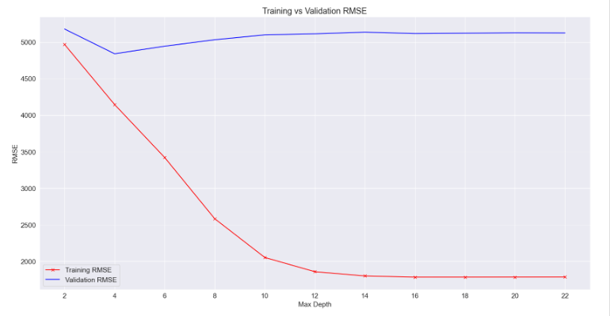
Tuning the hyperparameter max_depth involves finding the optimal depth for decision trees in the Random Forest model. In our analysis, we found that the model achieved the best performance when max_depth was set to 4. This depth provided a good balance between training and validation RMSE, indicating that deeper trees may lead to overfitting. Therefore, we will tune our Random Forest model with a max_depth of 4 to ensure it generalizes well to unseen data while avoiding overfitting.
Tuning the Hyperparameter ma_leaf_node
Our model achieved the lowest training and validation RMSE when max_leaf_nodes was set to 16. This indicates that a moderate number of leaf nodes in the decision trees leads to optimal model performance. Therefore, we will tune our model with max_leaf_nodes = 16 to ensure a balance between model complexity and generalization ability.
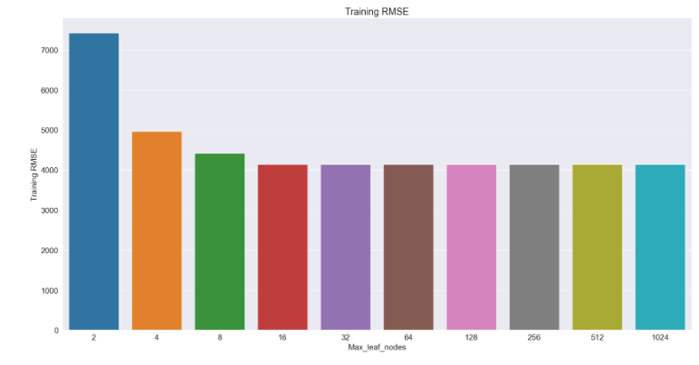
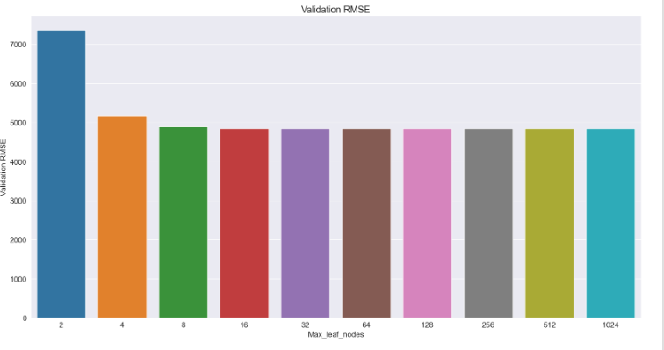
Model has lowest training and validation RMSE when max_leaf_nodes = 16

9.Result and Analysis
KNN Regressor on Testing data
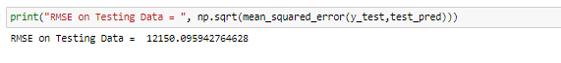
The project's results indicate poor model performance, reflected in a high RMSE of 12150.10 on the testing data. This signifies significant prediction errors when applied to new data, highlighting a lack of generalization. To address this, exploring alternative regression models and techniques is crucial. By experimenting with different algorithms, such as linear regression, decision trees, or random forests, and optimizing through feature engineering and hyperparameter tuning, we aim to improve accuracy. In summary, the high RMSE underscores the need for model reassessment and exploration of alternative approaches to enhance performance.
The formula for calculating the Root Mean Squared Error (RMSE) on testing data is:

Where:
- n is the number of observations in the testing data.
- yi is the actual value of the target variable for the i-th observation.
- ^yi is the predicted value of the target variable for the i-th observation.
Linear Regressor on Testing data
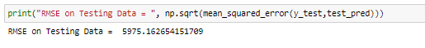
The Linear Regressor outperformed the KNN model on the testing data, yielding a substantially lower RMSE of 5975.16. This considerable reduction in RMSE underscores the superiority of the Linear Regression model in accurately predicting medical costs compared to the KNN model, which exhibited significantly higher errors. The results emphasize the importance of selecting appropriate regression techniques tailored to the dataset's characteristics to achieve superior predictive performance in healthcare cost estimation.
Decision tree Regressor on Testing data
The Decision Tree Regression model outperforms Linear Regression with a lower RMSE of 4485.31 on testing data. This indicates its suitability for medical cost prediction, possibly due to its ability to capture complex nonlinear relationships. Despite its success, the project aims to explore more regression techniques to enhance predictive accuracy further. This iterative approach emphasizes the project's dedication to optimizing cost estimation in healthcare.
Random Forest Regressor on Testing data
The Random Forest model has surpassed the performance of the Decision Tree model, as evidenced by its lower RMSE of 4297.03 on the testing data. This outcome suggests that the ensemble approach employed by Random Forest, which aggregates predictions from multiple decision trees, has further enhanced the model's predictive accuracy. The superior performance of the Random Forest model underscores the effectiveness of ensemble learning techniques in mitigating overfitting and improving generalization to unseen data. This result consolidates the project's objective of continually refining predictive models to achieve optimal performance in estimating medical costs.

10. Model Accuracy
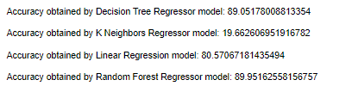

11. Reflect on professional, ethical, and legal issues in relation to the problem
In the realm of medical insurance cost prediction, several professional, ethical, and legal considerations come into play. Professionals in this field must ensure the responsible handling of sensitive personal and medical data, adhering to strict privacy regulations such as HIPAA. Ethically, there's a duty to ensure fairness and transparency in insurance pricing, avoiding discrimination based on factors like gender, race, or pre-existing conditions. Additionally, models must be carefully developed and validated to ensure accuracy and reliability, minimizing the risk of incorrect predictions that could impact individuals' access to healthcare. From a legal standpoint, compliance with data protection laws, regulatory guidelines, and industry standards is paramount to avoid legal liabilities and maintain trust among stakeholders.

12. Conclusion and Future Work
In our medical insurance cost prediction project, we explored various regression techniques, from KNN to Decision Tree and Linear Regression, culminating in Random Forest Regression. Each iteration aimed to enhance predictive accuracy and generalization ability. While KNN initially struggled with generalization, subsequent models, especially Random Forest Regression, significantly improved performance, surpassing Linear Regression and Decision Tree approaches. This journey highlights the importance of diversifying modelling techniques and leveraging ensemble methods like Random Forest to balance overfitting and maximize accuracy.
Moving forward, exploring techniques like Gradient Boosting or Support Vector Regression could further enhance accuracy. Refining feature engineering and selection processes may improve interpretability and efficiency. Expanding the dataset to include lifestyle factors and pre-existing conditions could enrich predictions and offer deeper insights. These approaches promise to refine models and provide more robust solutions for medical insurance cost prediction.

13. References
1. A. S. Raut and P, Comparative Study of Regression Models and Deep Learning Models for Insurance Cost Prediction, Springer International Publishing, vol. 1, 2019.

2. Y.-C. Kim, W.-S. Bak and S.-K. Lee, "A Study on the Factors Affecting the Arson", Fire Science and Engineering, vol. 28, no. 2, pp. 69-75, 2014.

3. J. Myers, C. G. de Souza e Silva, R. Doom, H. Fonda, K. Chan, S. Kamil-Rosenberg, et al., "Cardiorespiratory Fitness and Health Care Costs in Diabetes: The Veterans Exercise Testing Study", American Journal of Medicine, vol. 132, no. 9, pp. 1084-1090, 2019.

4. A. S. Raut and P, Comparative Study of Regression Models and Deep Learning Models for Insurance Cost Prediction, Springer International Publishing, vol. 1, 2019.

5. A. A. Kodi yan and K. Francis, Linear regression model for predicting medical expenses based on insurance data, December 2019.

6. Nidhi Bhardwaj and Rishabh Anand, "Health Insurance Amount Prediction", International Journal of Engineering Research And vol. 9, no. 05, pp. 1008-1011, 2020.

7. M. Hanafy and O. M. A. Mahmoud, "Predict Health Insurance Cost by using Machine Learning and DNN Regression Models", International Journal of Innovative Technology and Exploring Engineering, vol. 10, no. 2, pp. 137-143, 2021.

